

**DR. D. Y. PATIL SCHOOL OF SCIENCE AND TECHNOLOGY**

**TATHAWADE, PUNE**

**A Mini- Project Report on**

**“Fashion AI Bot (SlayBot)”**

**SUBMITTED BY:**

**NAME OF STUDENT ROLL NUMBER**

**1.Ishita Saxena BTAI-47**

**2.Ishwari Warhade BTAI-59**

**3.Himanshu Chaudhari BTAI-9**

**GUIDED BY:**

**Mrs Sonali Patil**

**ARTIFICIAL INTELLIGENCE & DATA SCIENCE**

**ACADEMIC YEAR 2024-2025**



**DR. D. Y. PATIL SCHOOL OF SCIENCE AND TECHNOLOGY**

**TATHAWADE, PUNE**

**CERTIFICATE**

**This is to certify that the Mini- Project Report entitled**

**-“Fashion AI Bot (SlayBot) “-**

is a bonafide work carried out by Ms. Ishita Saxenaunder the supervision of **Mrs Sonali Patil** and it is submitted towards the partial fulfillment of the requirement Artificial Intelligence.

Mrs Sonali Patil Ms. Mily Lal

**Project Guide HOD (DYPSST)**

**ARTIFICIAL INTELLIGENCE & DATASCIENCE**

**ACADEMIC YEAR 2024-2025**



**DR. D. Y. PATIL SCHOOL OF SCIENCE AND TECHNOLOGY**

**TATHAWADE, PUNE**

**CERTIFICATE**

**This is to certify that the Mini- Project Report entitled**

**-“Fashion AI Bot (SlayBot) “-**

is a bonafide work carried out by Ms. Ishwari Warhadeunder the supervision of **Mrs Sonali Patil** and it is submitted towards the partial fulfillment of the requirement Artificial Intelligence.

Mrs Sonali Patil Ms. Mily Lal

**Project Guide HOD (DYPSST)**

**ARTIFICIAL INTELLIGENCE & DATASCIENCE**

**ACADEMIC YEAR 2024-2025**



**DR. D. Y. PATIL SCHOOL OF SCIENCE AND TECHNOLOGY**

**TATHAWADE, PUNE**

**CERTIFICATE**

**This is to certify that the Mini- Project Report entitled**

**-“Fashion AI Bot (SlayBot) “-**

is a bonafide work carried out by Mr. Himanshu Chaudhariunder the supervision of **Mrs Sonali Patil** and it is submitted towards the partial fulfillment of the requirement Artificial Intelligence.

Mrs Sonali Patil Ms. Mily Lal

**Project Guide HOD (DYPSST)**

**ARTIFICIAL INTELLIGENCE & DATASCIENCE**

**ACADEMIC YEAR 2024-2025**

**ABSTRACT**

SlayBot is an AI-driven fashion assistant designed to provide personalized and interactive fashion recommendations. Using natural language processing (NLP), the bot understands user queries related to color combinations, outfits, fashion trends, style tips, and occasion-based dress advice. The assistant offers suggestions based on factors such as body type, undertones, and specific events, making it a versatile tool for individuals seeking fashion guidance. By analyzing user input, SlayBot can recommend trendy outfits, suitable color pairings, and unique styling tips that match the user's preferences, whether for casual outings, formal events, or special occasions like weddings or parties. SlayBot’s goal is to enhance the user's fashion experience by simplifying the decision-making process, making fashion advice easily accessible, and allowing users to curate outfits that match their individual style and needs. This makes SlayBot an essential tool for anyone looking to stay fashionable and confident with minimal effort.

Keywords: AI-powered fashion assistant, personalized fashion recommendations, color combinations, outfit ideas, body type advice, occasion-based styling.

|  |  |  |
| --- | --- | --- |
| **SR.NO** | **TOPIC** | **PAGE NO** |
| 1] | Introduction | 5-6 |
| 2] | System Architecture | 7 |
| 3] | Implementation of Code | 8-19 |
| 4] | Output | 20-22 |
| 5] | Conclusion & Future Scope | 23 |
| 6] | Reference | 24 |

**INDEX**

**List of Figures**

|  |  |  |
| --- | --- | --- |
| **SR.NO** | **FIGURE NO.** | **PAGE NO** |
| 1 | System Architecture | 7 |
| 2 | User interface output | 20 |
| 3 | Bot working output | 21 |
| 4 | Irrelevant questions asked output | 22 |

**Chapter 1**

**INTRODUCTION**

SlayBot is an innovative AI-powered fashion assistant designed to transform the way individuals approach their wardrobe choices. By integrating natural language processing (NLP) technology, SlayBot offers personalized fashion advice based on user preferences, body types, and specific occasions. This virtual assistant can help users with a range of fashion-related needs, including color combinations, outfit ideas, trending styles, and fashion tips, all tailored to their personal style.The core functionality of SlayBot revolves around its ability to interpret user input and generate relevant responses. Whether a user is looking for outfit inspiration for a wedding, seeking styling tips, or wondering what colors complement their skin tone, SlayBot responds with personalized suggestions. For instance, when asked for advice on what to wear for a formal event, SlayBot provides elegant and suitable outfit ideas. Similarly, it can recommend color pairings based on the user’s undertone or body type, ensuring that the advice is both practical and flattering.SlayBot offers an intuitive and interactive user interface, making it easy for users to engage in conversations. Users can request recommendations for casual, formal, or party outfits, ask about current fashion trends, and receive specific styling tips that reflect the latest fashion sensibilities. By utilizing machine learning and NLP, SlayBot continuously improves its responses, delivering more accurate and contextually relevant suggestions over time. This AI assistant provides a smart and accessible way to stay on top of personal fashion, allowing users to feel confident and stylish with ease.

**1.1 PROBLEM STATEMENT :**

To design an AI bot that provides personalized fashion recommendations based on color, body type, and occasion, aiming to simplify outfit selection. The bot offers users tailored advice, helping them make confident and informed fashion choices effortlessly.

**1.2 OBJECTIVES**

* To develop an AI-powered bot that suggests fashion outfits based on users' body types, color preferences, and occasions.
* To provide personalized color combinations and styling tips that align with users' undertones and fashion needs.
* To enhance user experience by offering real-time fashion trends and Outfit of the Day (OOTD) suggestions.
* To enable users to receive customized dress advice for specific events such as casual outings, formal gatherings, parties, and more.

**1.3 SCOPE**

* **Personalized Outfit Suggestions** based on body type, color preferences, and occasion.
* **Fashion Trend & Style Tips** for staying up-to-date with the latest fashion.
* **Occasion-based Outfit Recommendations** for events like weddings, parties, and work.
* **Color Coordination** based on users' undertones (cool, warm, neutral).
* **Interactive User Experience**, learning from user preferences for better suggestions.
* **E-commerce Integration** to help users purchase recommended outfits or similar items.

**Chapter 2**

**SYSTEM ARCHITECTURE**

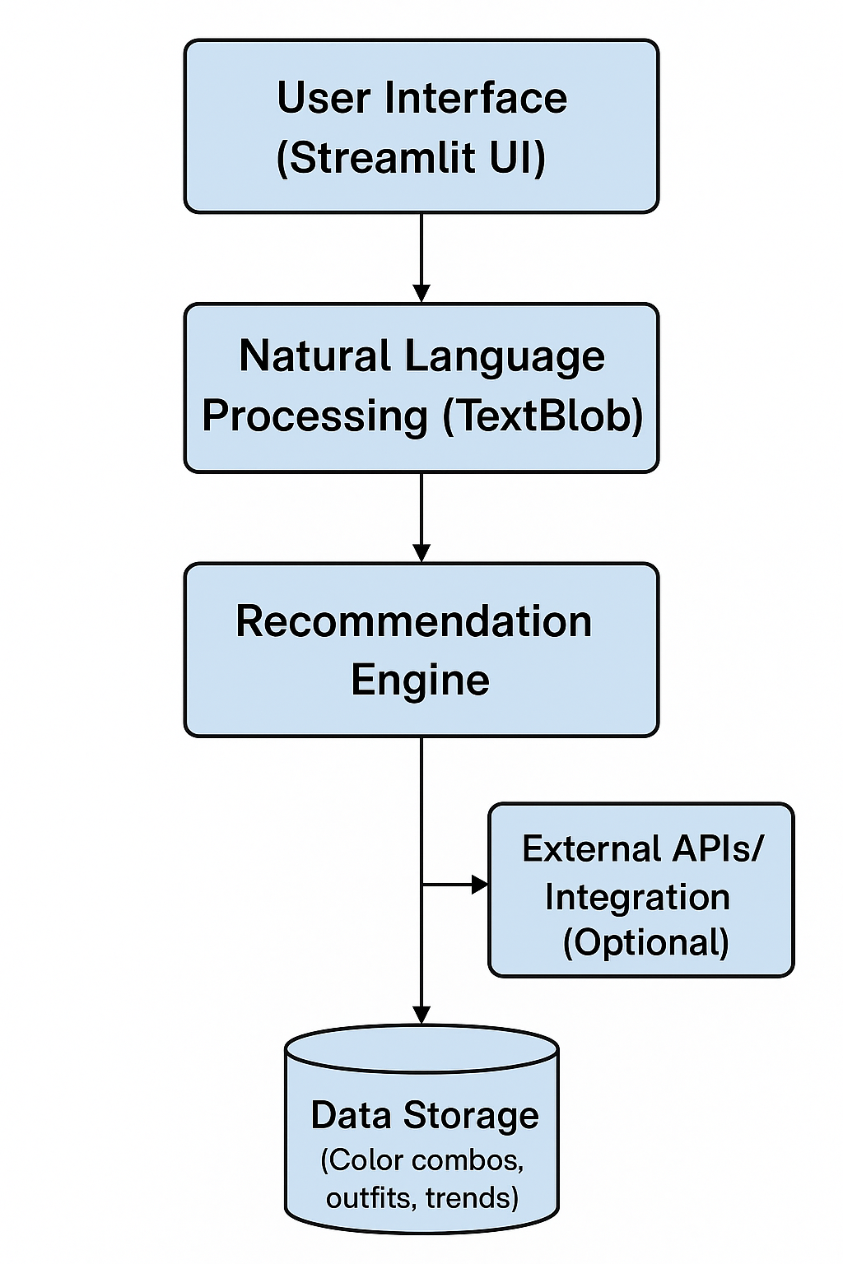

**Chapter 3**

**IMPLEMENTATION OF CODE**

import random

import streamlit as st

from textblob import TextBlob

COLOR_COMBINATIONS = {

"black": ["white", "gold", "red", "grey", "silver"],

"white": ["blue", "black", "pastel shades", "olive green", "lavender"],

"beige": ["pastel pink", "brown", "rust", "white"],

"navy blue": ["mustard yellow", "white", "grey", "light grey"],

"lavender": ["mint green", "grey", "white", "pastel pink"],

"red": ["denim blue", "black", "cream", "white", "gold"],

"olive green": ["cream", "rust", "white", "brown"],

"grey": ["black", "red", "navy blue", "pastel pink"],

"brown": ["beige", "cream", "mustard", "rust"],

"pastel pink": ["white", "beige", "light grey", "lavender"],

"mustard yellow": ["navy blue", "brown", "white", "olive green"],

"mint green": ["lavender", "white", "peach", "pink"],

"peach": ["mint green", "cream", "light brown"],

"denim blue": ["white", "red", "grey", "mustard"],

"rust": ["cream", "olive green", "brown", "beige"],

"cream": ["brown", "olive green", "pastel pink", "mint green"],

"light grey": ["navy blue", "white", "pastel tones", "black"],

"yellow": ["white", "blue", "black", "grey"],

"orange": ["white", "brown", "beige", "green"],

"green": ["white", "black", "peach", "yellow", "denim blue"],

"blue": ["white", "yellow", "grey", "pink"],

"purple": ["white", "pink", "grey", "black"],

"pink": ["white", "light grey", "beige", "lavender"],

"gold": ["black", "emerald green", "white", "red"],

"silver": ["black", "navy blue", "white"]

}

FASHION_TRENDS = [

"Y2K aesthetic",

"Oversized blazers",

"Baggy jeans & crop tops",

"Statement belts",

"Chunky sneakers",

"Matching coords",

"Minimalist neutral tones",

"Sporty streetwear",

"Utility fashion with pockets",

"Denim on denim",

"Sheer fabrics & mesh tops",

"Corset tops",

"Platform boots",

"Graphic tees with vintage vibes",

"Layered necklaces & stacked rings",

"Maxi skirts with slits",

"Satin slip dresses",

"Balaclavas & funky headwear",

"Tote bags with quotes",

"Monochrome outfits",

"Retro sunglasses",

"Cargo pants",

"Puffy jackets & bomber styles",

"Lace & leather mix",

"Asymmetrical cuts"

]

OOTD_SUGGESTIONS = [

"High-waist jeans + relaxed tee + sneakers",

"Oversized shirt + straight pants + crossbody bag",

"Flared trousers + plain tee + boots",

"Denim jacket + cargo pants + basic tee",

"Co-ord set + minimal accessories",

"Satin shirt + wide-leg jeans + heels",

"Crop top + midi skirt + sandals",

"Slip dress + denim jacket + ankle boots",

"Graphic tee + pleated skirt + chunky sneakers",

"Corset top + ripped jeans + strappy heels",

"Turtleneck + mini skirt + knee-high boots",

"Off-shoulder top + mom jeans + platform sneakers",

"Basic tank + palazzo pants + statement earrings",

"Blazer dress + belt + thigh-high boots",

"Baggy hoodie + biker shorts + dad sneakers",

"Mesh top + bralette + wide-leg trousers",

"Oversized sweater + skater skirt + ankle boots",

"Crop hoodie + joggers + high-top sneakers",

"Lace top + leather pants + kitten heels",

"Asymmetrical top + culottes + mules"

]

STYLE_TIPS = [

"Add a belt to instantly elevate a simple dress.",

"Layering is key for a stylish and dynamic outfit.",

"Mix textures like denim, leather, and cotton for contrast.",

"Always balance oversized and fitted pieces.",

"Accessories can change the entire vibe of your outfit.",

"Tuck in your top to define your waist and elongate your legs.",

"Statement earrings can glam up even the most basic look.",

"Play with proportions to add dimension and interest.",

"Use a pop of color in your bag or shoes for bold impact.",

"Monochrome outfits always look effortlessly chic.",

"Don’t be afraid to mix prints—stripes and florals can totally work.",

"Neutral tones are timeless and easy to style.",

"A good pair of sunglasses adds instant edge.",

"Sneakers go with more than just casual outfits—rock them with dresses too.",

"Roll up your sleeves or pants slightly to show off bracelets or shoes.",

"Confidence is your best accessory—wear it loud!",

"Invest in quality basics—they’re your everyday fashion foundation.",

"Know your body type and dress to highlight your best features.",

"Don’t follow trends blindly—make them work for *your* vibe.",

"Add one standout piece to every outfit for a signature slay."

]

UNDERTONE_RECOMMENDATIONS = {

"cool": "Cool undertones look great in jewel tones like emerald, sapphire, and amethyst. Silver jewelry enhances the look.",

"warm": "Warm undertones shine in earthy tones like orange, brown, yellow, and gold. Gold jewelry complements this the best.",

"neutral": "Neutral undertones can pull off a wide range of colors, including both cool and warm shades, like muted greens, blush, and navy."

}

BODY_TYPE_RECOMMENDATIONS = {

"hourglass": "Try fitted tops and pencil skirts or high-waisted pants to accentuate your curves. Avoid overly baggy clothes.",

"pear": "A-line dresses and skirts, as well as top-heavy outfits (like puff sleeves), balance your proportions. Avoid wide-leg pants.",

"apple": "Empire waistlines and flowy dresses will add shape without clinging to your midsection. Go for V-necklines to elongate your torso.",

"rectangle": "Define your waist with belted dresses or tops, and create curves with peplum designs. Layering works great for you."

}

OCCASION_DRESS_ADVICE = {

"casual": [

"For a casual day out, go for comfortable yet stylish options like a loose tee, denim jeans, and sneakers.",

"A pair of leggings, oversized sweater, and ankle boots make a perfect casual outfit.",

"Casual dresses with floral prints, paired with flat sandals, work great for warm weather."

],

"formal": [

"For formal events, opt for tailored suits, dresses with clean lines, or a fitted blazer.",

"A sleek, monochrome dress with minimal accessories is perfect for a formal dinner.",

"A high-waisted pencil skirt and a fitted blouse paired with heels is ideal for a business formal look."

],

"party": [

"A party look should include bold pieces like a bodycon dress or sequined top paired with heels.",

"For a fun night out, a mini skirt with a cropped top and stilettos makes a trendy party outfit.",

"Rock a metallic dress with statement earrings and a clutch bag for a chic party look."

],

"date": [

"For a romantic date, opt for a flowy midi dress paired with soft curls and a pair of ballet flats.",

"A cute off-shoulder blouse with skinny jeans and a pair of wedges is perfect for a casual date.",

"A fitted dress with a cinched waist and heels works wonders for a dinner date."

],

"wedding": [

"For a wedding guest, a floral wrap dress or an elegant cocktail dress paired with nude heels works well.",

"Opt for a long, flowing gown with a subtle shimmer for a sophisticated wedding look.",

"A pastel-colored dress with minimal jewelry and a chic clutch is a safe bet for a wedding event."

],

"work": [

"A button-down shirt tucked into a high-waisted skirt or tailored trousers gives a professional yet stylish vibe.",

"A shift dress with a blazer is always a go-to work outfit.",

"Opt for a structured blazer over a blouse and straight-leg trousers for a power look at work."

],

"vacation": [

"For a beach vacation, go for a flowy sundress, sandals, and a wide-brimmed hat.",

"A comfy pair of shorts, a tank top, and slip-on shoes are perfect for exploring a new city on vacation.",

"When traveling to cooler destinations, opt for a cozy sweater, jeans, and a stylish jacket."

],

"brunch": [

"For brunch, go for a cute wrap dress or a skirt with a tucked-in blouse, paired with comfortable flats.",

"A pair of high-waisted trousers with a tucked-in button-up shirt makes a fashionable and effortless brunch look.",

"A casual yet chic romper with espadrilles works great for a daytime brunch."

]

}

class SlayBot:

def __init__(self):

pass

def extract_color(self, prompt):

blob = TextBlob(prompt)

for word in blob.words:

word_lower = word.lower()

if word_lower in COLOR_COMBINATIONS:

return word_lower

return None

def extract_undertone(self, prompt):

prompt = prompt.lower()

if "cool" in prompt:

return "cool"

elif "warm" in prompt:

return "warm"

elif "neutral" in prompt:

return "neutral"

return None

def extract_body_type(self, prompt):

prompt = prompt.lower()

if "hourglass" in prompt:

return "hourglass"

elif "pear" in prompt:

return "pear"

elif "apple" in prompt:

return "apple"

elif "rectangle" in prompt:

return "rectangle"

return None

def extract_occasion(self, prompt):

prompt = prompt.lower()

if "casual" in prompt:

return "casual"

elif "formal" in prompt:

return "formal"

elif "party" in prompt:

return "party"

return None

def respond(self, prompt):

prompt = prompt.lower()

if "color" in prompt or "goes with" in prompt or "match with" in prompt or "color combo" in prompt:

color = self.extract_color(prompt)

if color:

options = COLOR_COMBINATIONS[color]

return f"{color.title()} pairs well with {', '.join([c.title() for c in options])}. Try mixing and matching!"

else:

return "I couldn't detect the base color. Try rephrasing your question."

elif "trend" in prompt or "trending" in prompt or "what's in" in prompt:

return f"Hot trend alert! {random.choice(FASHION_TRENDS)} is super in right now."

elif "ootd" in prompt or "outfit" in prompt or "wear" in prompt or "today" in prompt:

return f"Here's an outfit idea for you: {random.choice(OOTD_SUGGESTIONS)}"

elif "tip" in prompt or "advice" in prompt or "style me" in prompt:

return f"Style tip: {random.choice(STYLE_TIPS)}"

elif "help" in prompt or "what can you do" in prompt:

return ("SlayBot can help you with:\n"

"- Color combinations (e.g., 'What goes with red?')\n"

"- Latest fashion trends (e.g., 'What's trending?')\n"

"- Outfit of the day ideas (e.g., 'Give me an OOTD')\n"

"- Styling tips (e.g., 'Give me a fashion tip')\n"

"- Undertone advice (e.g., 'What colors suit my cool undertone?')\n"

"- Body type recommendations (e.g., 'What should I wear for an hourglass figure?')\n"

"- Occasion-based dress advice (e.g., 'What should I wear to a party?')")

elif "undertone" in prompt:

undertone = self.extract_undertone(prompt)

if undertone:

return UNDERTONE_RECOMMENDATIONS[undertone]

return "Please mention whether your undertone is cool, warm, or neutral."

elif "body type" in prompt:

body_type = self.extract_body_type(prompt)

if body_type:

return BODY_TYPE_RECOMMENDATIONS[body_type]

return "Please mention your body type (hourglass, pear, apple, rectangle)."

elif "occasion" in prompt:

occasion = self.extract_occasion(prompt)

if occasion:

return OCCASION_DRESS_ADVICE[occasion]

return "Please mention the occasion (casual, formal, party)."

else:

return "Hmm... I'm not sure I understood that. Try asking about colors, trends, outfits, or styling tips."

# Streamlit UI

bot = SlayBot()

st.set_page_config(page_title="SlayBot - AI Fashion Assistant", page_icon="🧥")

st.title("🧥 SlayBot - Your AI Fashion Assistant")

st.markdown("_Talk to your AI stylist! Ask about colors, trends, outfits or tips._")

if "history" not in st.session_state:

st.session_state.history = []

user_input = st.chat_input("Ask me something fashionable...")

if user_input:

response = bot.respond(user_input)

st.session_state.history.append((user_input, response))

for q, a in st.session_state.history:

with st.chat_message("user"):

st.write(q)

with st.chat_message("assistant"):

st.write(a)

**Chapter 4**

**OUTPUT**

**User Interface**

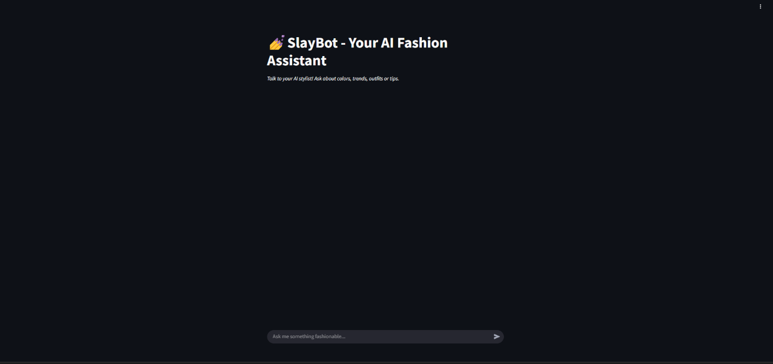

**What all the bot can do**

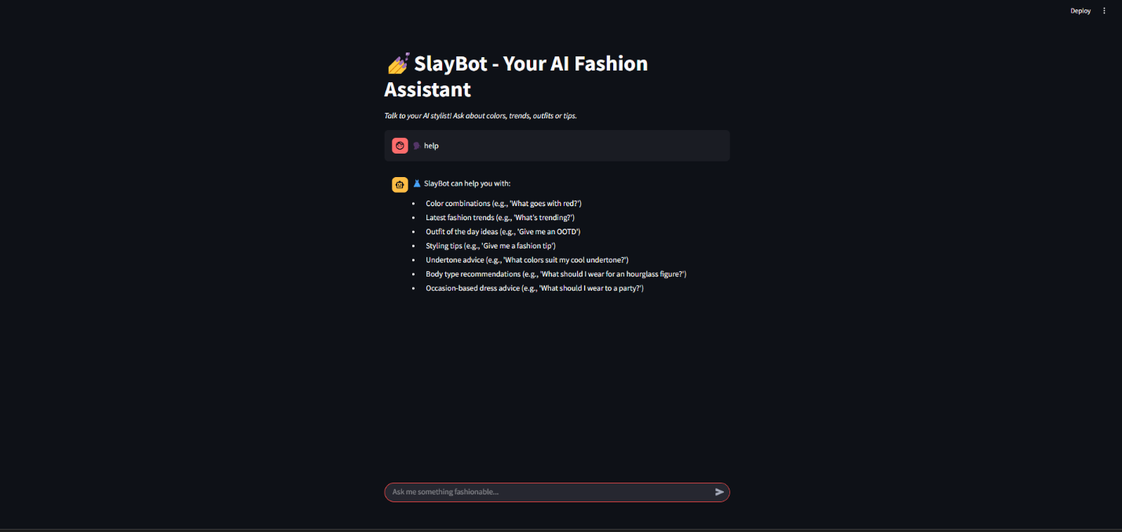

**How this works**

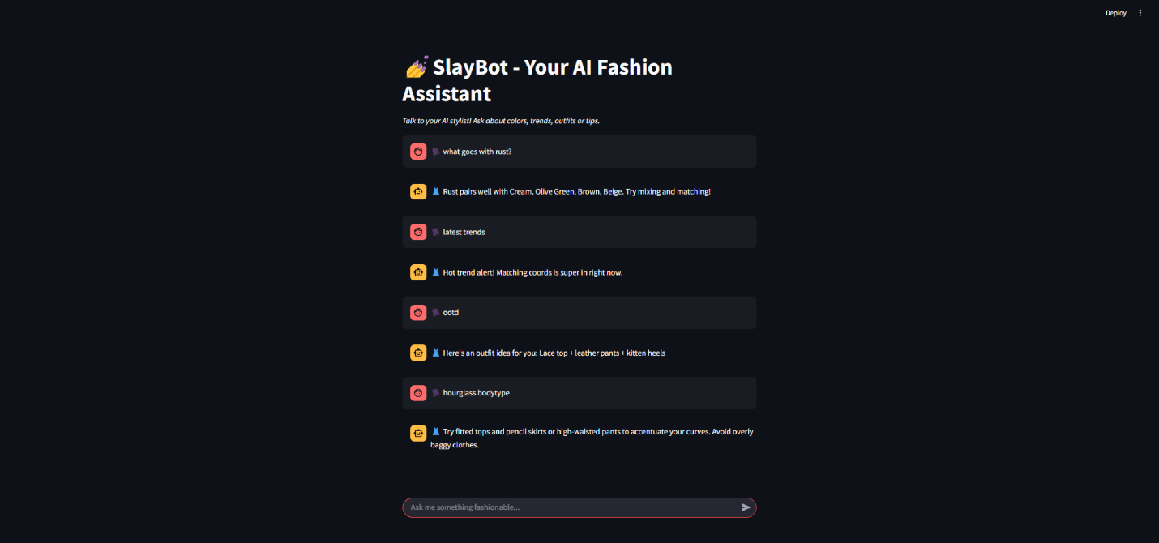

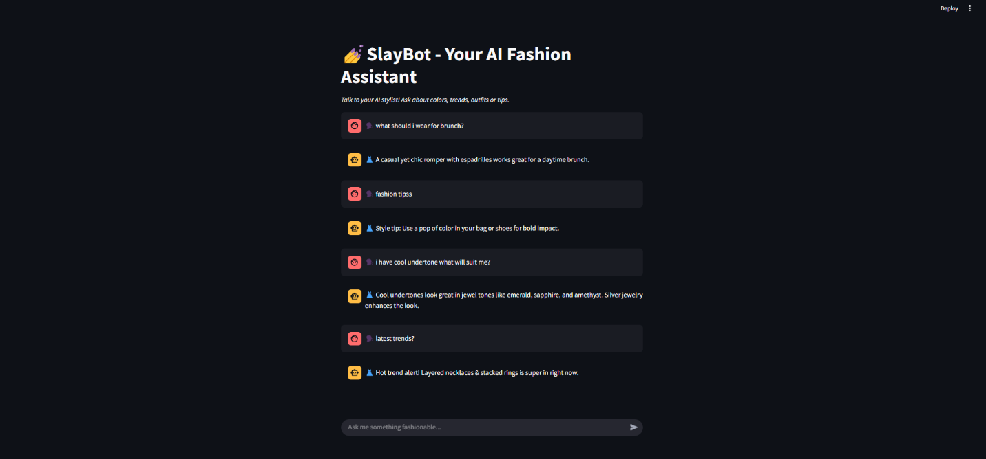

**When asked irrelevant questions**

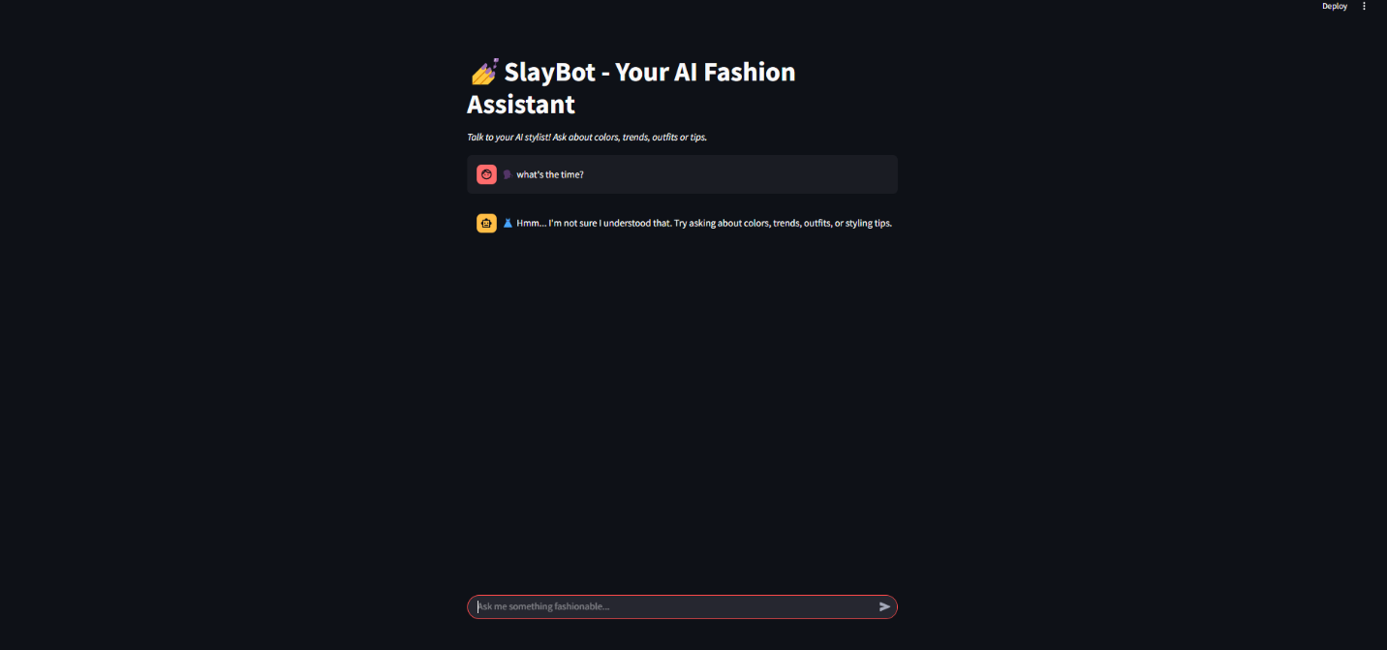

**Chapter 5**

**CONCLUSION & FUTURE SCOPE**

**5.1 CONCLUSION**

The development of the **SlayBot AI Fashion Assistant** marks a significant advancement in personalized fashion guidance. By leveraging AI technologies, the bot helps users effortlessly navigate style decisions, providing tailored recommendations based on factors such as color preferences, body types, occasions, and fashion trends. The implementation of natural language processing allows users to interact with the bot intuitively, creating an engaging and personalized experience. The scope of the application can easily be expanded to include additional features like trend forecasting and integration with e-commerce platforms for real-time shopping suggestions. By blending technology with fashion, **SlayBot** not only empowers users to enhance their personal style but also contributes to the growing trend of AI-driven personalization in various industries. Moving forward, the app could be further refined to improve its accuracy and expand its offerings, positioning it as a valuable tool in the evolving world of AI-assisted fashion.

**5.2 FUTURE SCOPE**

Thought for a couple of seconds

* **Real‑time E‑commerce Integration:** Link outfit suggestions directly to online stores for seamless shopping.
* **Image‑based Styling:** Allow users to upload photos of clothing items to get matching recommendations.
* **Trend Forecasting Module:** Use machine learning to predict upcoming fashion trends and update the bot’s suggestions.
* **AR Virtual Try‑On:** Incorporate augmented reality so users can “try on” outfits before purchasing.
* **Multilingual Support:** Expand SlayBot’s NLP to handle multiple languages and regional style nuances.

**Chapter 6**

**REFERENCES**

* TextBlob. (n.d.). Retrieved from <https://textblob.readthedocs.io/>
* Streamlit. (n.d.). Retrieved from <https://streamlit.io/>
* Zheng, L., et al. (2018). Fashion Recommendation Systems: A Review. *International Journal of Computer Science and Information Security*, 16(3), 107-112. Retrieved from <https://www.researchgate.net/publication/322727417_Fashion_Recommendation_Systems_A_Review>
* Fashion-MNIST. (n.d.). Retrieved from <https://github.com/zalandoresearch/fashion-mnist>